# Figures

## Figure 1A

## Figure 1B

## Figure 1C

## Figure 1D

## Figure 1E

## Figure 1F

## Figure 2A

## Figure 3A

## Figure 3B

## Figure 3C

## Figure 3D

## Figure 3E

## Figure 3F

## Figure 3G

## Figure 3H

## Figure 3I

## Figure 4A

## Figure 4B

## Figure 4C

## Figure 4D

## Figure 4E

## Figure 4F

## Figure 4G

## Figure 4H

## Figure 4I

## Figure 4J

## Figure 4K

## Figure 4L

## Figure 4M

## Figure 5A

## Figure 6A

## Figure 6B

## Figure 6C

## Figure 6D

## Figure 6E

## Figure 6F

## Figure 6G

## Figure 6H

## Figure 6I

## Figure 6J

## Figure 6K

## Figure 6L

## Figure 6M

## Figure 6N

## Figure 7A

## Figure 7B

## Figure 7C

## Figure 7D

## Figure 7E

## Figure 7F

## Figure 7E

## Figure 7G

## Figure 7H

## Figure 7I

## Figure 7J

## Figure 8A

## Figure 8B

## Figure 8C

## Figure 8D

## Figure 8E

## Figure 8F

## Figure 8G

## Figure 8H

## Figure 8I

## Figure 8J

## Figure 8K

## Figure 8L

## Figure 8M

## Figure 8N

## Figure 8O

## Figure 8P

## Figure 8Q

## Figure 8R

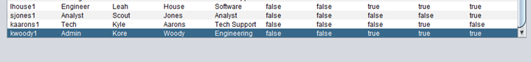

## Figure 8S

## Figure 8T

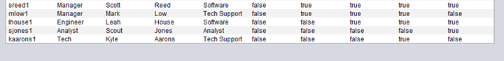

## Figure 9A

## Figure 9B

## Figure 9C

## Figure 9D

## Figure 9E

## Figure 9F

## Figure 9G

